# **LINUX IN WINDOWS**

# 

# **How to Install & Enable WSL in Windows**

Windows Subsystem for Linux (WSL) lets you run a Linux dev environment directly on your Windows machine without the need for a virtual machine.

1. **To install WSL on Windows 11, open PowerShell or Command Prompt (admin), run the “wsl –install” command, and restart the computer.**

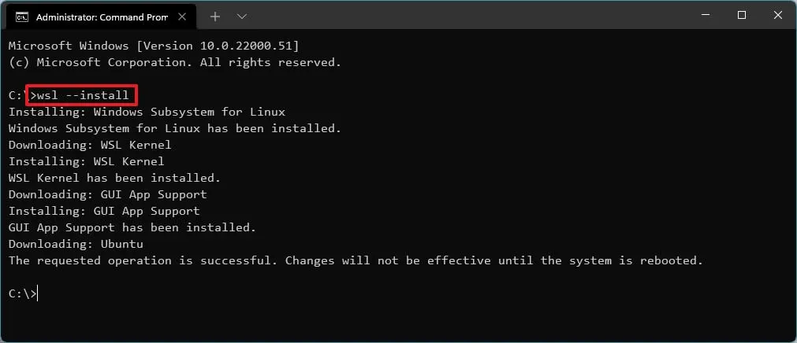

The command will install WSL alongside the Ubuntu distribution.

**2. Or, to install WSL with a specific distro, run the “wsl –install -d DISTRO-NAME” command.**

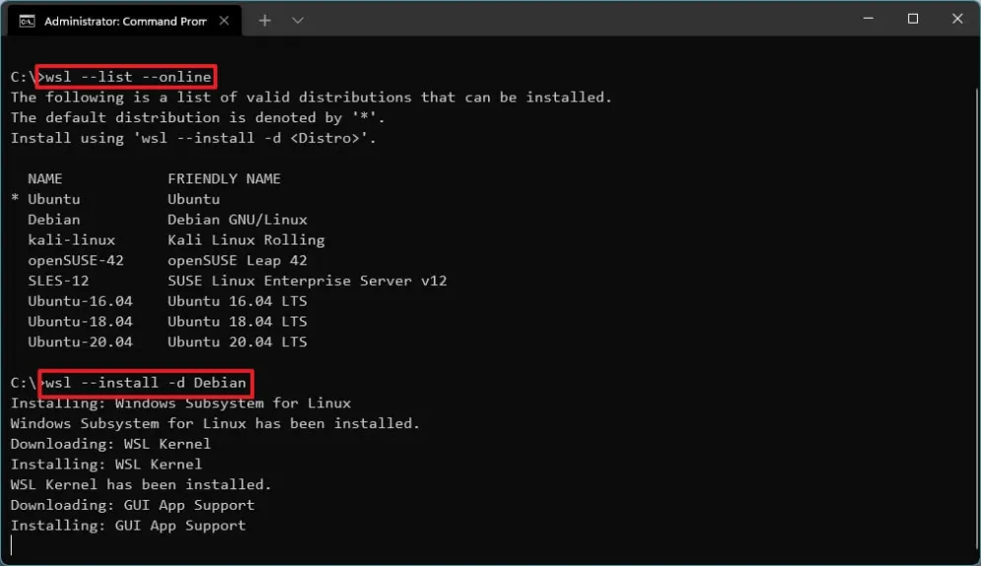

3. **Or, to install WSL from Microsoft Store, enable the “Virtual Machine Platform” feature and then download the WSL app from the Store.**

### **Enable Virtual Machine Platform**

* Open Start.
* Search for Turn Windows Features on or off and click the top result to open the app.

Check the Virtual Machine Platform option.  
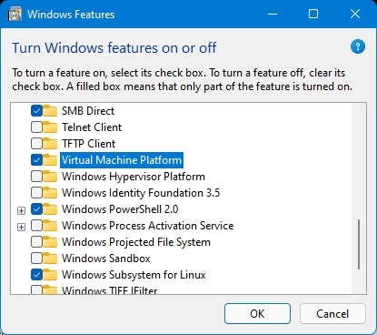

* Click the OK button.
* Click the Restart button.
* After completing the steps, you can download the app from the Microsoft Store.

### **Install Windows Subsystem for Linux app**

* [Open the Windows Subsystem for Linux store page](https://www.microsoft.com/en-us/p/windows-subsystem-for-linux-preview/9p9tqf7mrm4r?activetab=pivot:overviewtab).
* Click the Get button.
* Click the Open button.

Click the Get button again.  
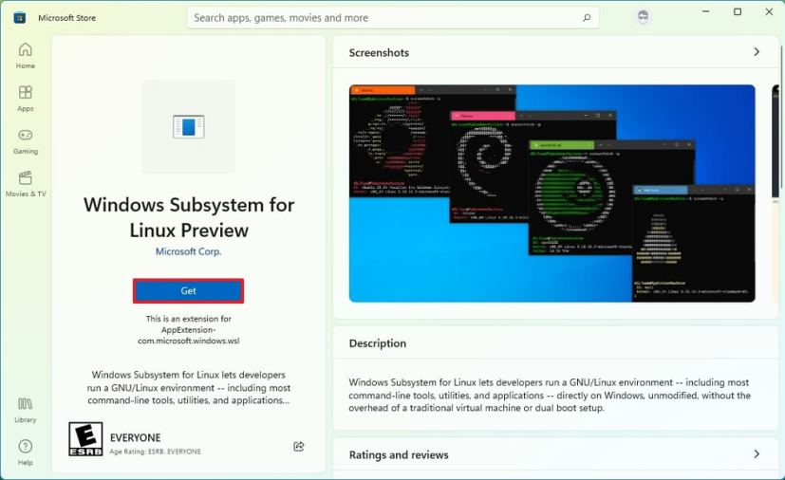

### 

### 

### 

### 

### 

### 

### 

### 

### 

### 

### **3. Install Linux distro**

Open Microsoft Store app.

Search for the Linux distro. For example, [Debian](https://www.microsoft.com/store/productId/9MSVKQC78PK6).

Click the Get button.  
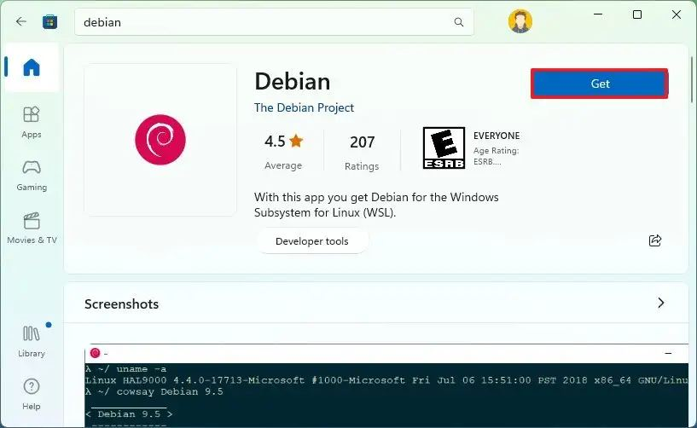

Click the Open button.

Once you complete the steps, WSL will install on Windows 11, including the support for Linux GUI apps and the Linux distribution.